**8. Diffraction Grating**

**Objective:** To Find the Wavelength of monochromatic light with the help of a plane transmission diffraction grating and spectrometer.

**Apparatus**: A spectrometer, a sprit level, a source of monochromatic light (sodium lamp), diffraction grating with clamping arrangement.

**Formula Used:**

The wavelength ’λ’ of any spectral line can be calculated by the formula (a+b) sin θ = nλ

or, λ = {(a+b) sin θ} /n

where, (a+b) = grating element

θ = angle of diffraction

n = order of spectrum

**Theory:**

A plane diffraction grating consists of an optically plane glass plate on which large no. of equidistant parallel lines are ruled. These lines divide the glass plate into opacities and transparencies, the thickness of which are of the order of the wavelength of the visible light. The region where a line is drawn becomes opaque and the space between the two lines is transparent.

When a parallel beam of monochromatic light is incident normally on the grating, it suffers diffraction. The transmitted light gives rise to primary maxima in certain directions given by the relation, (a+b) sin θ = nλ as shown in the Figure 1, where ‘a’ is the width of transparency and ‘b’ is that of opacity. θ is the angle of diffraction for nth order maxima and λ is the wave length of light.



**Figure 1**

For the first order spectrum, n = 1

Therefore, (a+b) sin θ1 = λ

For the second order spectrum, n = 2

and (a+b) sin θ2 = 2λ

The number of lines N per inch are marked on the grating. The value of the grating element (a+b) is given by, (a + b) =  cm.

**Spectrometer:** An Spectrometer is basically an instrument for measuring the angular deviation of light ray. A prism produces this angular deviation of light ray or grating, which is wavelength dependent. The emergent light from these component is dispersed into a spectrum in which wavelength is a function of angle. Spectrometer consists of mainly three parts: Collimator, Prism table and Telescope.

**Procedure:**

Adjustment of Spectrometer: Before starting the experiment, spectrometer should be adjusted properly so that chances of any error should be removed. Spectrometer is so adjusted that the axis of collimator and telescope intersect each other on the vertical axis of telescope. The prism table is horizontal, and telescope and collimator are focused for the parallel rays.

**Set the plane of grating normal to the incident light**

Place the telescope in line with the collimator so that the vertical cross wire falls exactly in the center of the image of the slit. Note the scale reading. Add 900 to the reading and place the telescope at this reading to set it perpendicular to the axis of collimator. Clamps it in this position.

Rotate the table till the plane face of the grating is facing both the collimator and the telescope. Look through the telescope and turn the table very slowly till the center of the slit falls exactly on the vertical cross wire as shown in Figure 2. In this position the plane of the grating is inclined at an angle of 450 to the incident light. Note the reading. Turn the table through 450 from this position so that the plane of the grating is normal to the incident light with its plane face towards collimeter. The grating is now set normal to the incident light with its ruled surface away from collimator. Clamp the table in this position.



**Figure 2**

**The slit should be adjusted parallel to the lines of the grating**

For this setting, the slit is rotated in its own plane till the spectral lines become very sharp and straight.

**Determination of angle of diffraction**

The spectrum obtained in the grating is shown in the figure 3.

1.Rotate the telescope to the left side of direct image, adjust the different spectral lines (colors) turn by turn on the vertical cross wire for the first order and not down the corresponding readings of both the verniers.

2.Rotate the telescope further to obtain the second order spectrum and again adjust the different spectral lines on the vertical cross wire and note down the corresponding readings.

3.Now rotate the telescope to the right of the direct image and repeat the above procedure for first order as well as for second order.

4.Find the difference of the same kind of verniers for each spectral line in the first order and then second order. The difference in the two readings of same vernier of same color and same order is the angle, which is twice of the angle of diffraction for the observed order and color. Half of it will be the angle of diffraction.

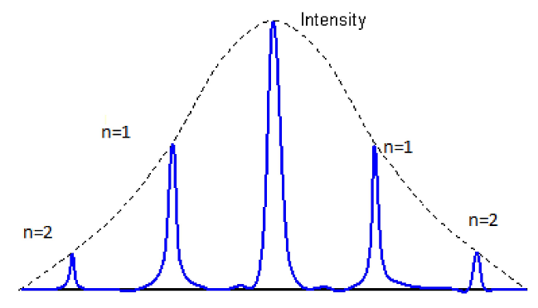

**Figure 3 Diffraction pattern by diffraction grating for white light (in monochromatic light the pattern will be of same colour)**

**Observations:**

**Observation**

**(a) Determination of Least Count of Spectrometer:**

Reading of one smallest division on M.S. ’a’ =……………degree

Total no. of division on Vernier Scale ‘b’ =…………..

Least Count of Spectrometer = a/b = …………….degree =…………….minute

**(b) Determination of Grating Element of Diffraction Grating:**

No. of lines per inch on the grating ‘N’= …………….

∴ Grating element =……………….cm =………………. Å

**(c) Determination of angle of Diffraction ‘θ’ :**

|  |  |  |  |  |  |  |  |  |  |  |
| --- | --- | --- | --- | --- | --- | --- | --- | --- | --- | --- |
| **Order of Spectrum** | **No of Vernier Scale: V1,V2** | **Reading of the Telescope for left side Spectrum** | | | **Reading of the Telescope for right side Spectrum** | | | **Angle ‘2θ’ = a-b (deg-min-sec)** | **Mean ‘2θ’ (deg-min-sec)** | **Angle ‘θ’ (deg-min-sec)** |
| **M.S. Reading**  **(deg-min-sec)** | **V.S. Reading**  **(div.)** | **Total Reading ‘a’**  **(deg-min-sec)** | **M.S. Reading**  **(deg-min-sec)** | **V.S. Reading**  **(div.)** | **Total Reading ‘b’**  **(deg-min-sec)** |
| First | V1 |  |  |  |  |  |  |  |  |  |
| V2 |  |  |  |  |  |  |  |
| Second | V1 |  |  |  |  |  |  |  |  |  |
| V2 |  |  |  |  |  |  |  |

**Calculations:**

***First Order Spectrum:***

Wavelength of spectral lines of first order (n=1) can be calculated by –

λ1 = (a+b) sin θ

λ**1** =……… …. Å

Calculate λ for other spectral lines.

***Second Order Spectrum:***

Wavelength of spectral lines of second order (n=2) is given by-

λ2 = {(a+b) sin θ2} / 2

λ**2** =……… …. Å

Mean of λ=(λ1+λ2)/2 Å

**Result:**

The wavelength of the given monochromatic light is …….. Å.

**Pcentage error:**

% Error = [(Standard value-Experimental value) x100]/Standard value

**Precautions :**

1. The axis of the telescope, the collimator and the plane of the prism table should be horizontal.

2. The position of the eyepiece should be adjusted so that the cross wires are clearly visible.

3. The telescope should be focused for infinity and the collimator should be adjusted to give a parallel

beam of light.

4. The slit should be narrow.

5. The diffraction grating should be parallel to the slit.

6. Both the Verniers should be read to avoid error due to the non-coincidence of the center of the

circular scale with the axis of rotation of the telescope or the table.